
RAMAIAH
Institute of Technology
USN | 1 | M | S

(Autonomous Institute, Affiliated to VTU)
(Approved by AICTE, New Delhi & Govt. of Karnataka) Accredited by NBA & NAAC with ‘A’ Grade

MAKEUP EXAMINATIONS – FEBRUARY 2019

Course & Branch | : | B.E: Electrical and Electronics Engineering | Semester | : | V
Subject | : | Control Systems | Max. Marks | : | 100
Subject Code | : | EE52/EE502 | Duration | : | 3 Hrs

Instructions to the Candidates:
- Answer one full question from each unit.

 |  | UNIT- I
1. | a) | Differentiate open loop and closed loop control systems with an example for each. | CO1 | (08)
 | b) | Define transfer function? And Briefly explain the need for modeling of a system. | CO1 | (06)
 | c) | Obtain the transfer function of the following circuit diagram Fig 1. (c)  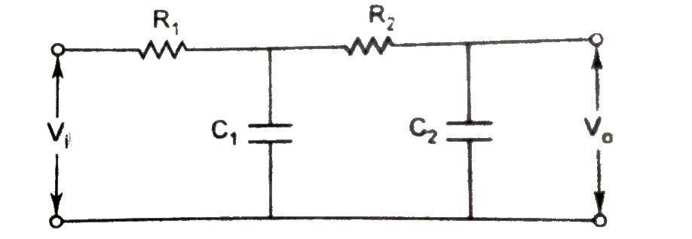  Fig 1. (c) | CO1 | (06)
2. | a) | Obtain the transfer function of the following system given in Fig. 2(a). Also obtain the equivalent circuit model by i) F-V analogy and ii) F-I analogy.  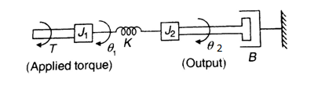  Fig 2. (a) | CO1 | (12)
 | b) | Derive transfer function of armature controlled separately excited DC servo motor. Consider position and voltage as output and input, respectively. | CO1 | (08)
 |  | UNIT-II
3. | a) | Draw the transient response of a second-order system and define all the specifications for the under-damped case. | CO2 | (08)
 | b) | Consider a unity feedback system with a closed TF  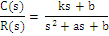  Determine the open-loop TF G(s). Show that the steady-state error with unit ramp input is given as . | CO2 | (08)
 | c) | Reduce the above block diagram to single TF. Fig 3(c).  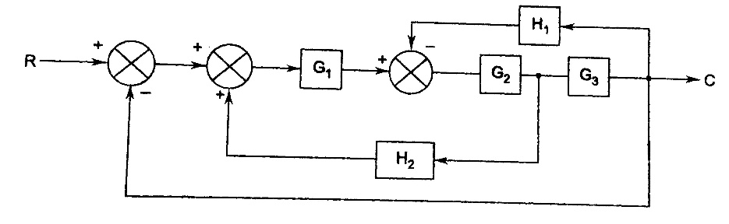  Fig. 3(c) | CO2 | (04)
4. | a) | Derive an expression form the time response 'c(t)' of a standard 2nd order under damped system. Hence define and derive the expression for peak overshoot and rise time. | CO2 | (12)
 | b) | Obtain the transfer function 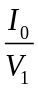from the following circuit diagram (Fig. 4(a)  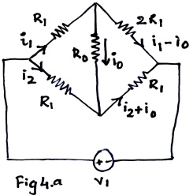 | CO2 | (08)
 |  | UNIT- III
5. | a) | For a unity feedback system having forward path T F  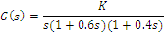  Determine using RH criterion  - The range values of K for which system is stable.  - Marginal value of K  - Frequency of sustained oscillations. | CO3 | (08)
 | b) | Plot the root locus of the system with OLTF 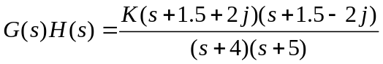, Comment on its stability. | CO3 | (12)
6. | a) | Plot the root locus of the system with OLTF 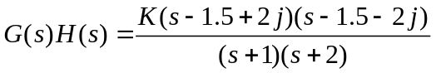, Comment on its stability. | CO3 | (14)
 | b) | Define the following terms:  (i) absolute or asymptotic stability  (ii) marginal stability  (iii) conditional stability  (iv) critically stable system | CO3 | (06)
 |  | UNIT- IV
7. | a) | A unity feedback system has open loop transfer function, 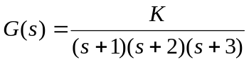. Draw the Nyquist diagram and find the range of values of K for which the system remains stable. | CO3 | (12)
 | b) | Draw polar plot of 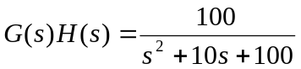 | CO3 | (08)
8. | a) | The open loop transfer function of a unity feedback system is 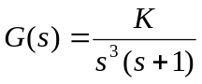. Draw the Nyquist plot and investigate the stability of the system. | CO3 | (12)
 | b) | Define:  - Resonant peak  - Resonant frequency  - Bandwidth  - Cut off rate. | CO4 | (08)
 |  | UNIT- V
9. | a) | Draw the Bode plot for the following system and comment on the stability. Find GM and PM.  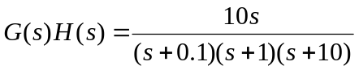 | CO1 | (14)
 | b) | For a series RLC circuit with R=10ohm, L=5mH, C=500nF, find the frequency domain specifications. If R is changed to 10MΩ , compare  i) The frequency response  ii) The Time response  with the same setup. | CO1 | (06)
10. | a) | Define i) Gain Margin ii) Phase margin of a system. Hence mention the conditions for stability of a system. | CO4 | (06)
 | b) | Obtain the transfer function from the following bode diagram Fig. 10(a)  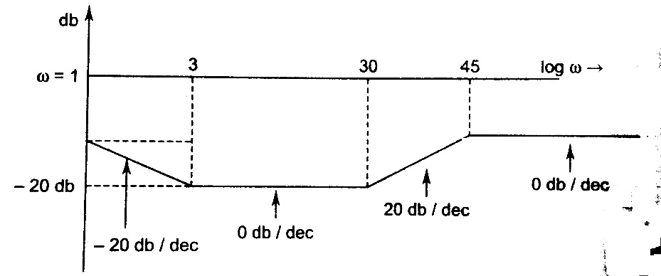  Fig. 10(a) | CO1 | (14)

***************

